Course: DevOps Name: Billipati Sai Teja

Module: AWS & Services Batch no: 115

Topic: EBS & EFS Assignment no: 08

Trainer Name: Mr. Madhukar sir Date of submission: 11th – Feb – 2024

Mail-ID: ([BILLIPATISAITEJA@GMAIL.COM](mailto:BILLIPATISAITEJA@GMAIL.COM))

**1.To create one EBS (Elastic Block Store) volume and attach it to 3 instances**

Sign in to the AWS Management Console.

click on "Security Groups".

Click the "Create Security Group" button.

In the "Create Security Group" wizard, configure the security group settings:

Enter a name for the security group in the "Security group name" field.

Optionally, enter a description for the security group in the "Description" field.

Select the VPC (Virtual Private Cloud) where you want to create the security group (in this it was in default mood).

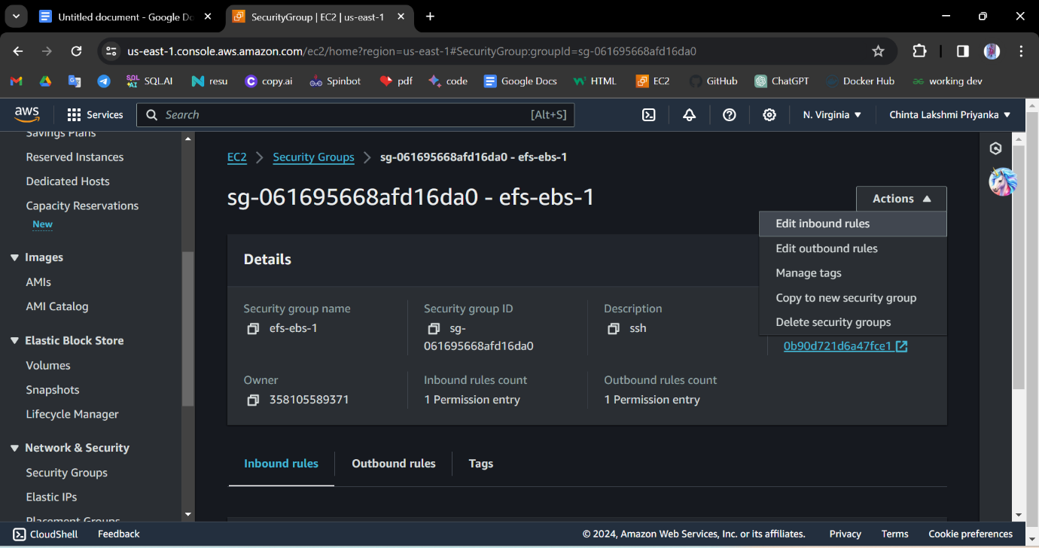

In the "Inbound Rules" section, define the inbound traffic rules for the security group. You can add rules based on your application's requirements, such as allowing SSH (port 22) or HTTP (port 80) traffic. Click the "Add Rule" button to add rules.

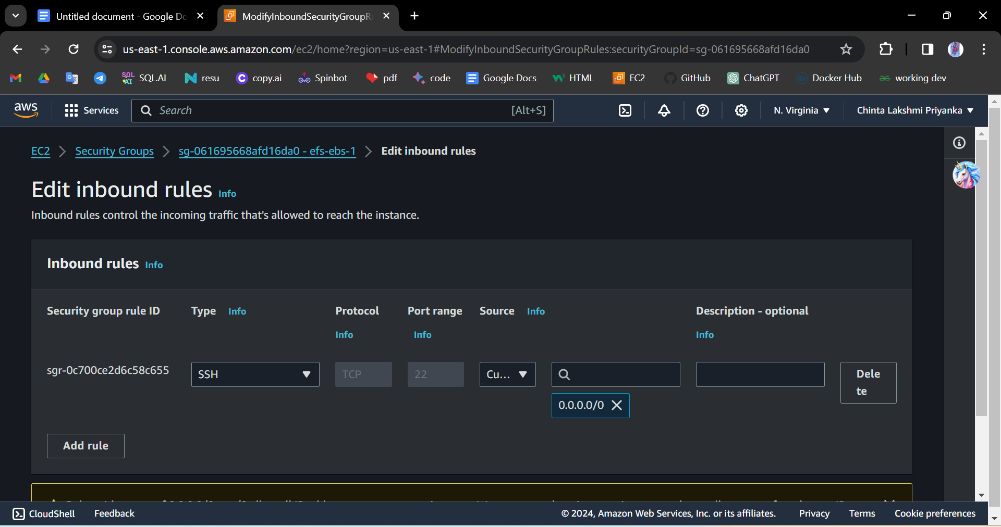

Click the "Create" button to create the security group.

Now create ebs

1. **Open the Amazon EC2 console at** [**https://console.aws.amazon.com/ec2/**](https://console.aws.amazon.com/ec2/)**.**
2. In the navigation pane, click on "Volumes".
3. 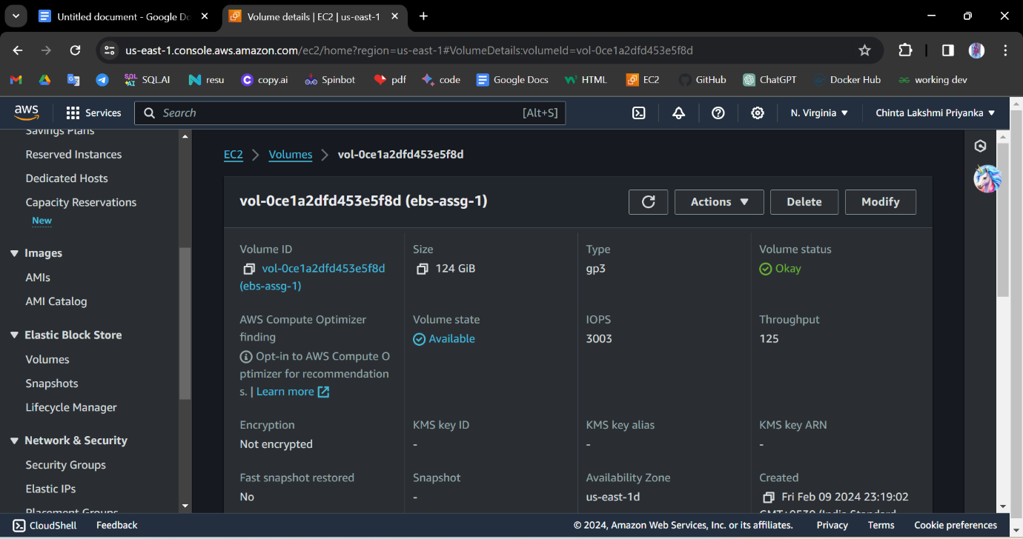Click the "Create Volume" button.
4. In the "Create Volume" wizard, configure the volume settings:
   * Select the desired Volume Type, Size, Availability Zone, and other settings according to your requirements.
5. Click the "Create" button to create the EBS volume.
6. Once the volume is created, note down the Volume ID.
7. Now go to the EC2 instance and create 3 instances 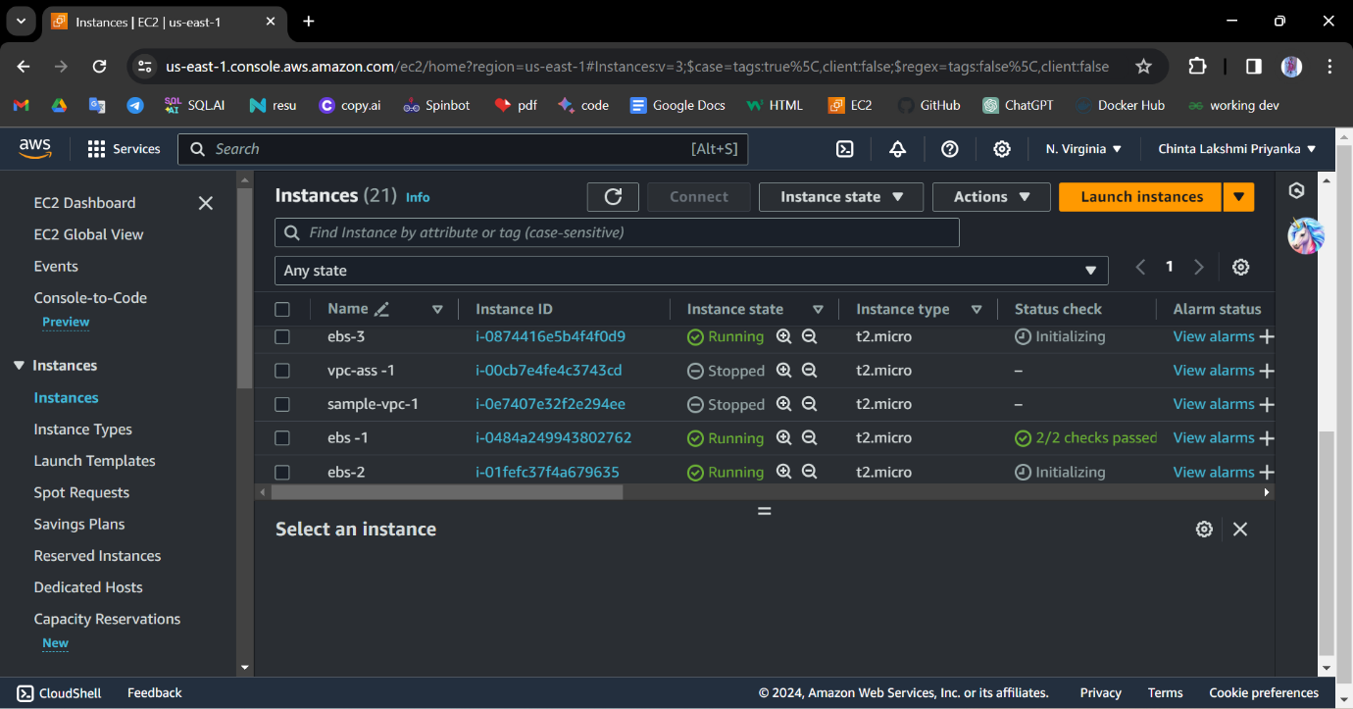
8. In the navigation pane, click on "Instances" and select the instances you want to attach the EBS volume to.
9. Click on the "Actions" button and select "Attach Volume".
10. 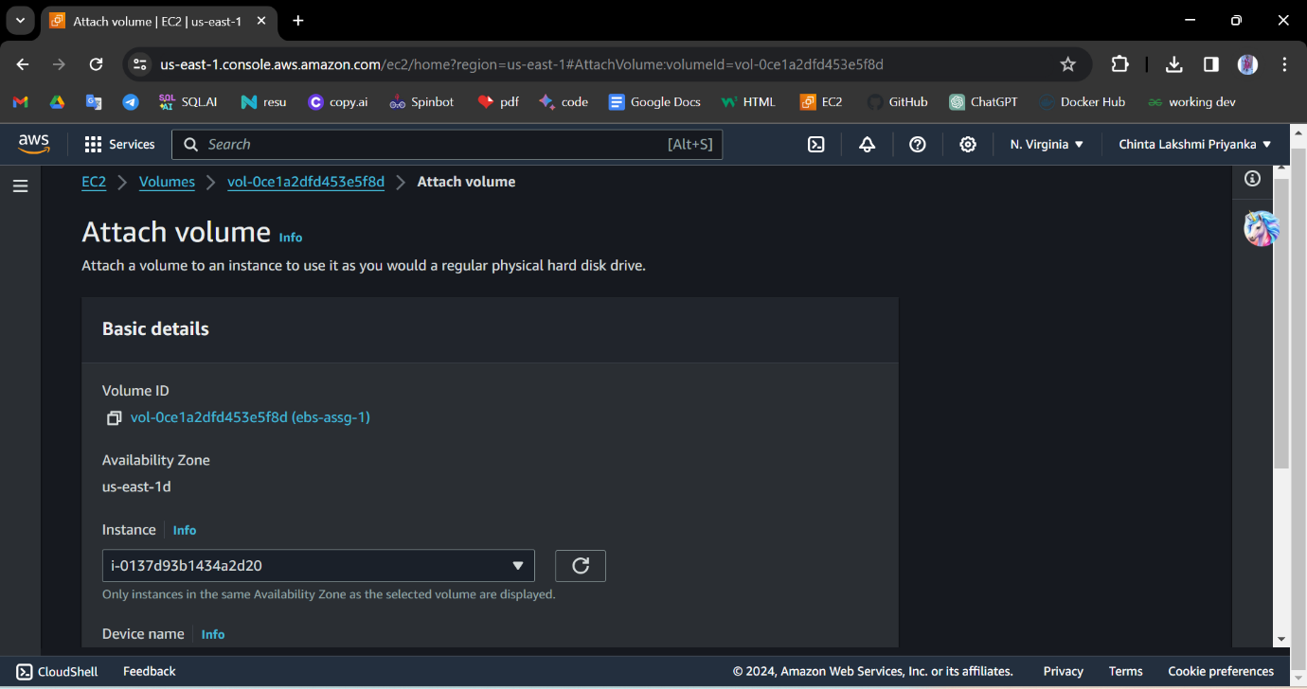Attach the first instance to ebs volume.

Now, Connect the instance

To create a file system on an EBS (Elastic Block Store) volume after connecting it to an instance, you can follow these steps:

1. 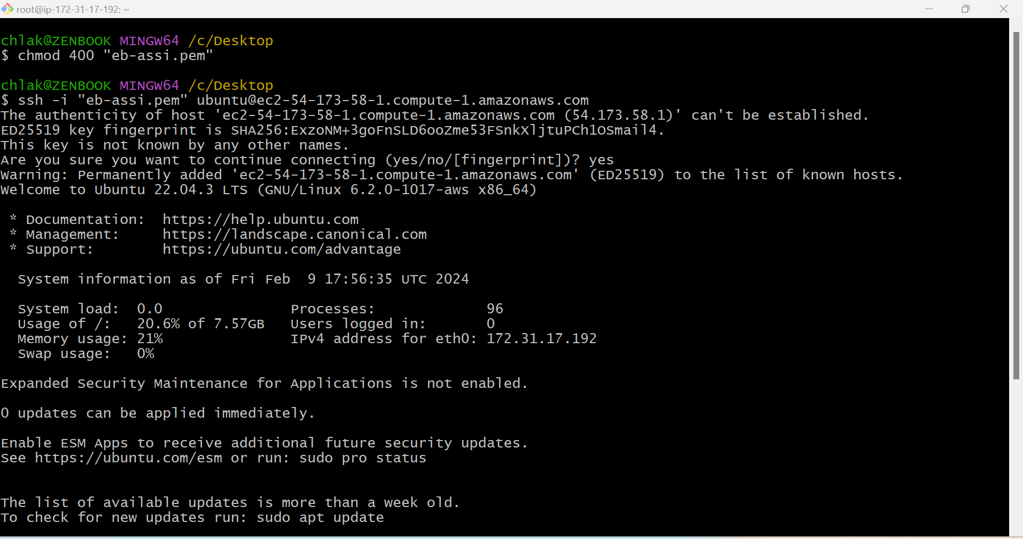Connect to the instance that has the EBS volume attached using SSH or any other remote access method.
2. Once connected to the instance, you need to identify the device name of the EBS volume that you want to create a file system on. **lsblk**

This command will display a list of available block devices, including the attached EBS volume. It will show the device name (e.g., /dev/xvdf, /dev/sdf) of the volume you want to use for creating the file system.

**To create file system**:

mkfs -s /dev/xvdf

**To create directory:**

mkdir -p aws/v1&v2

1. After the file system is created, you may need to mount it to a directory so that you can access and use it.

mount /dev/xvdf aws/v1

1. You can verify the mounted file system by using the df -h command, which lists the file systems and their mount points.

df -h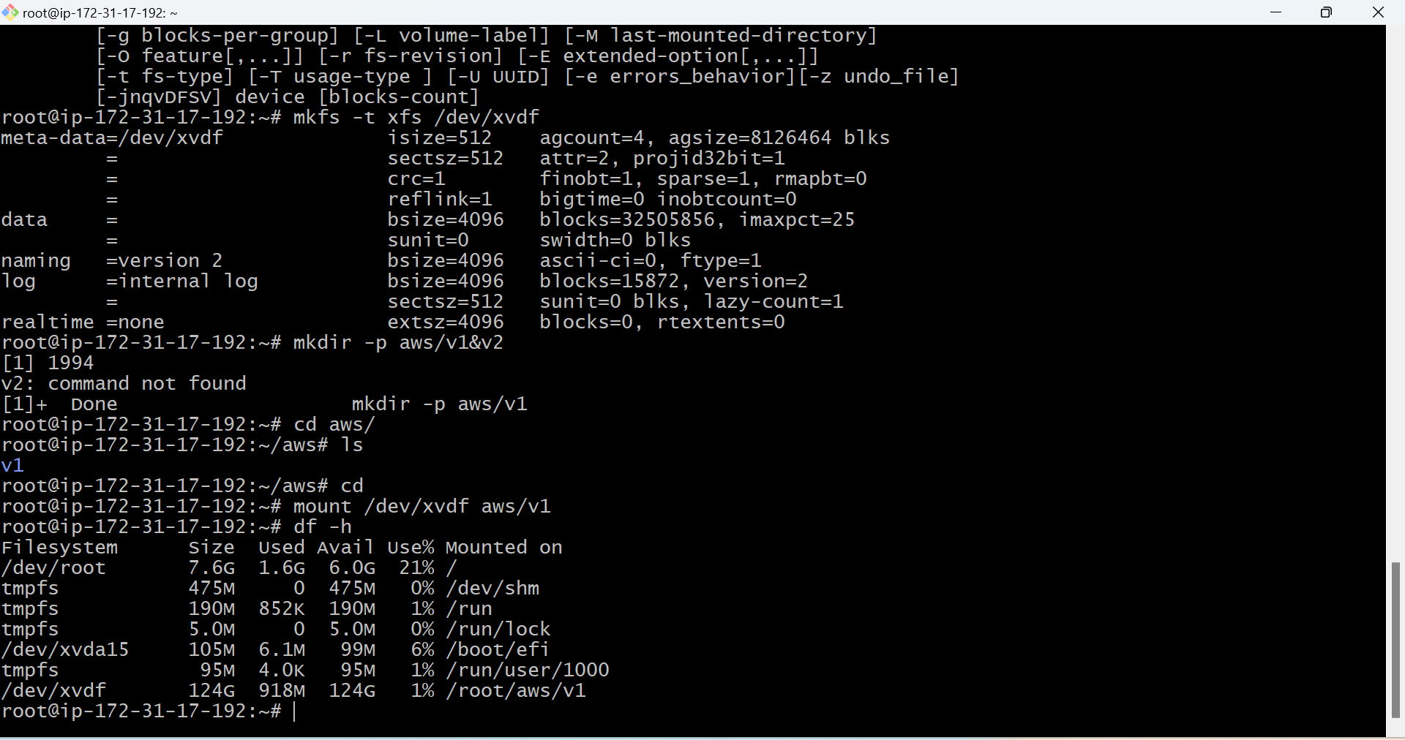

Now, you should have successfully created a file system on the EBS volume and mounted it to the desired directory on the instance.

Now detach the volume and attach it to another ebs-2 instance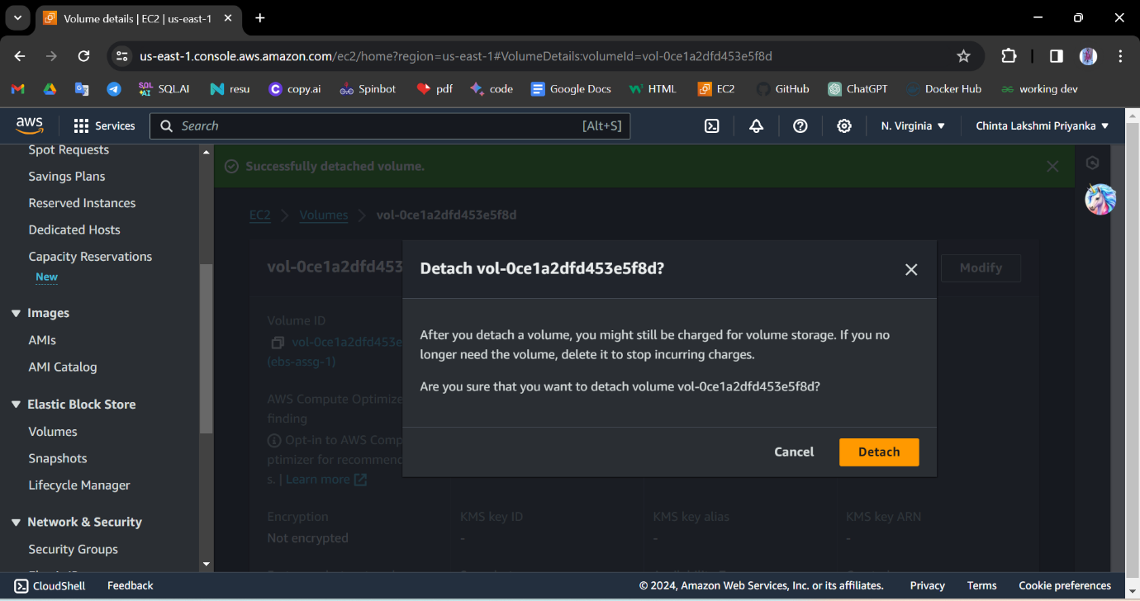

Attach to the second volume.

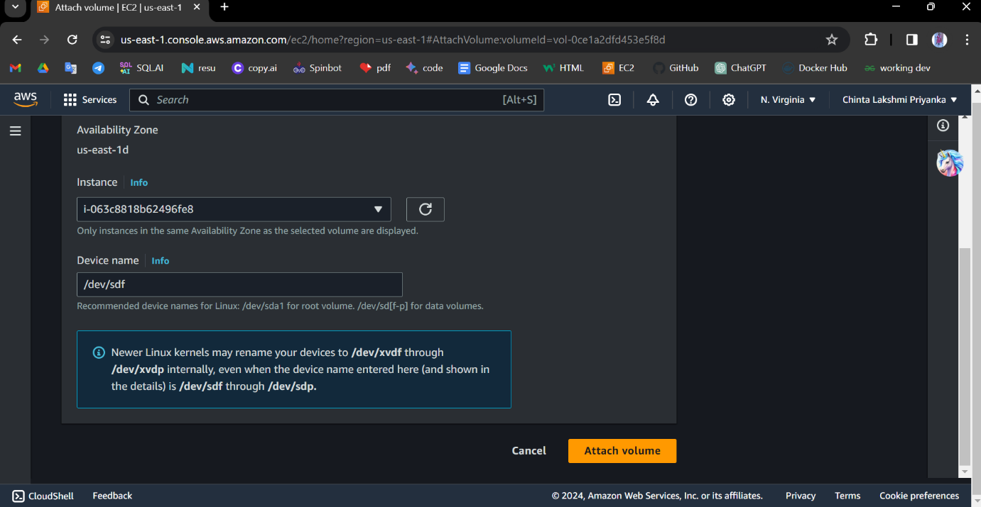Now check whether the file system is created or not.

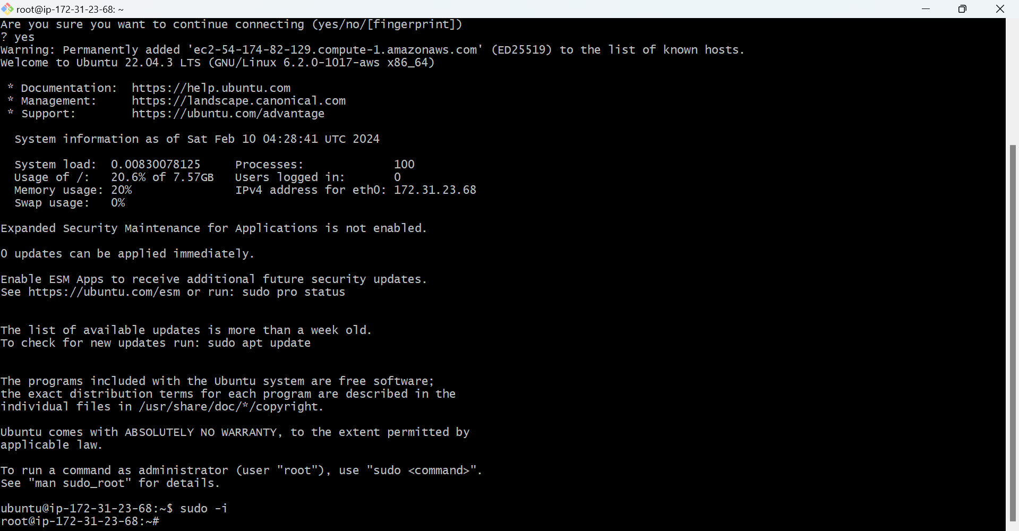And check whether the file system is created or not.

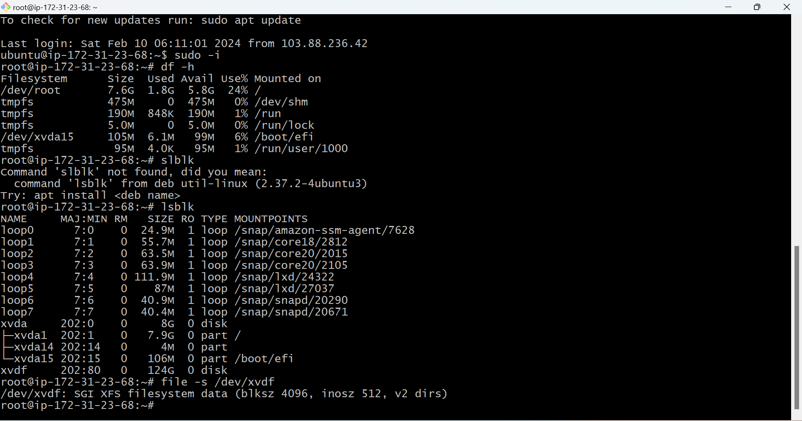

It was created. It shows that the already file exists.

Let's detach this volume and attach it to another to the third volume.

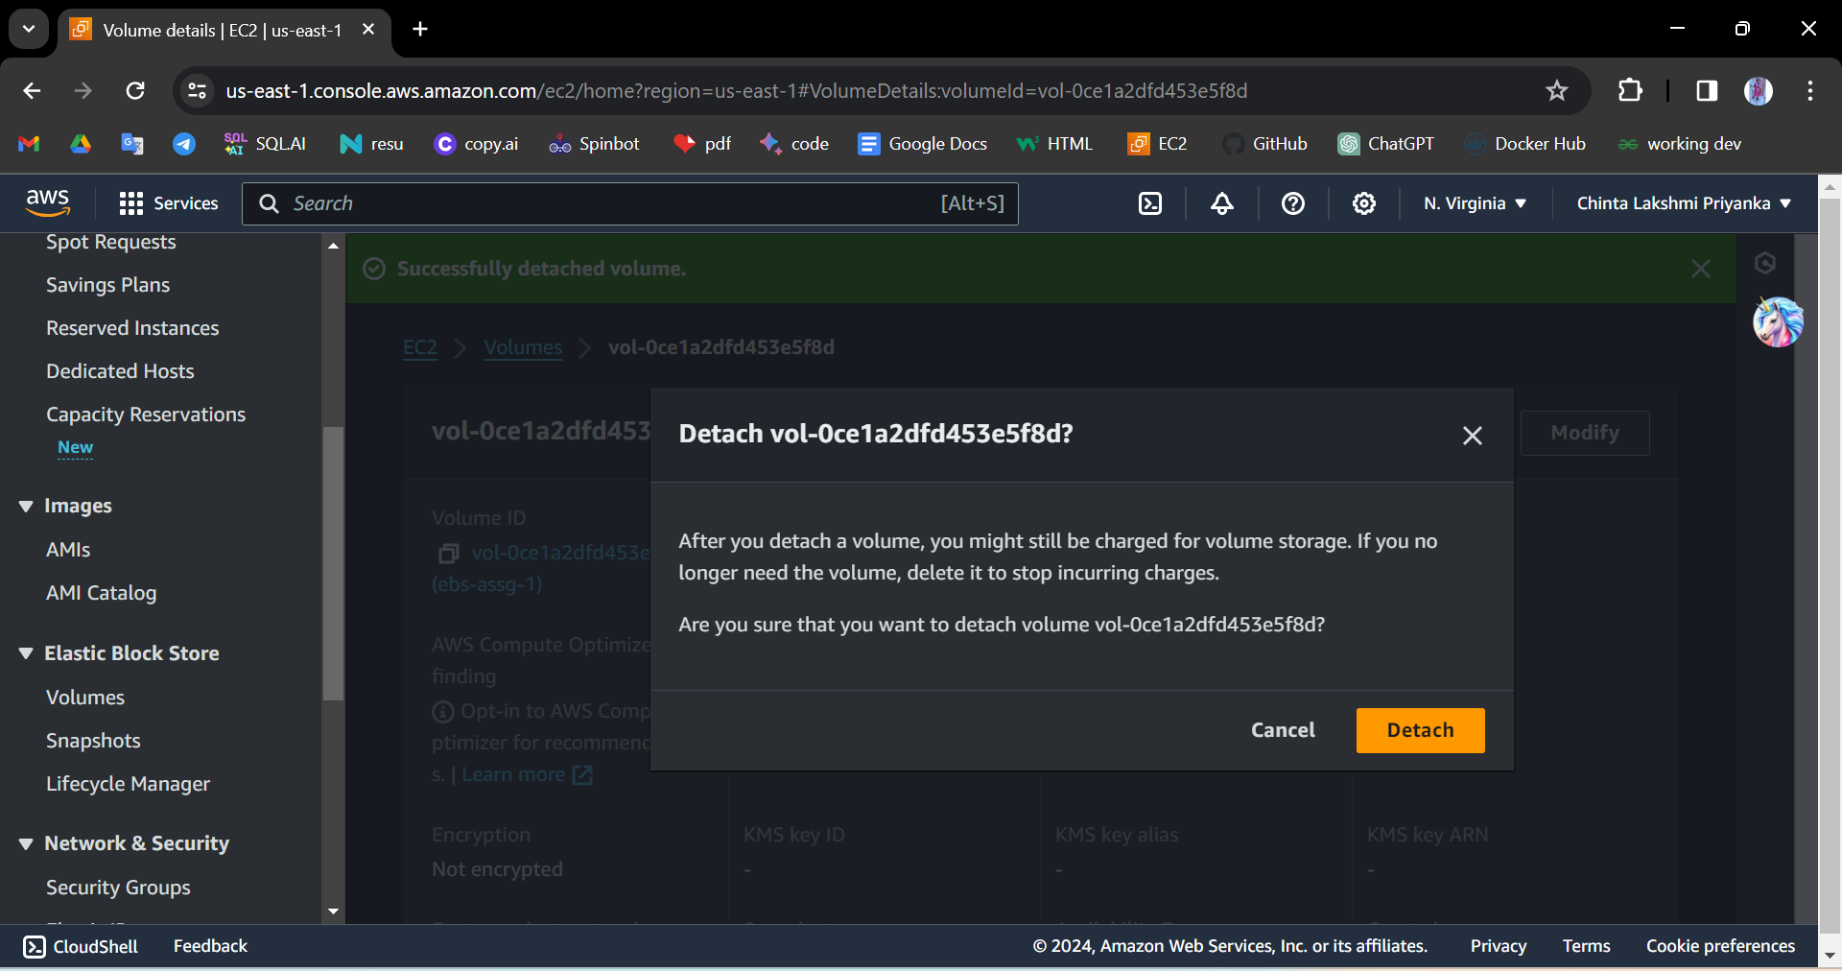

Now attach it to the third volume.

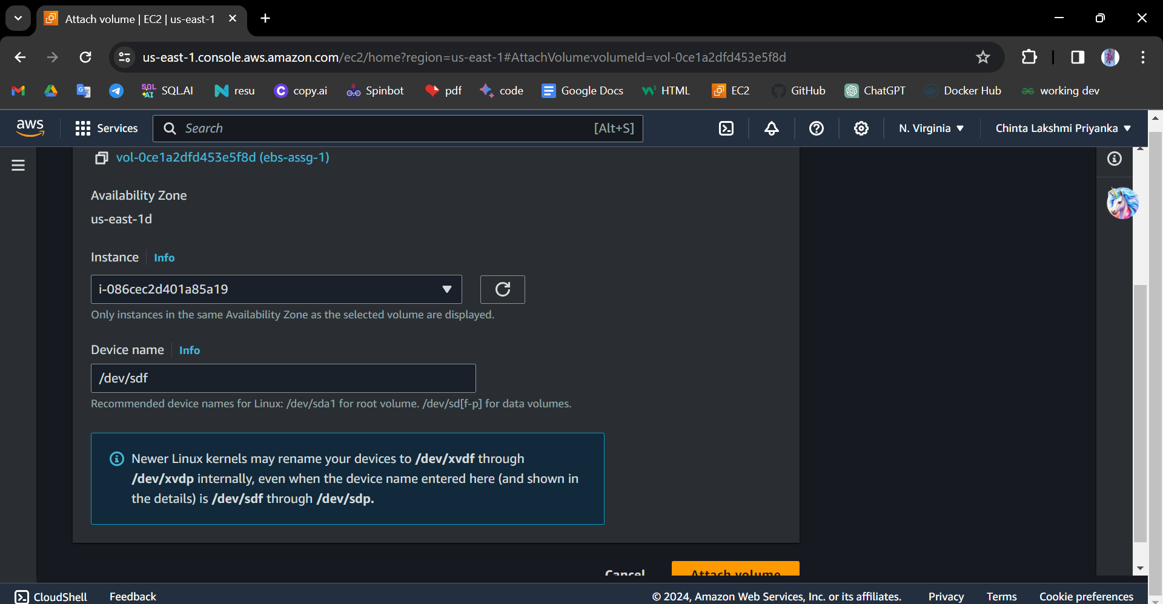

Now connect the instance and check whether the file exits or not.

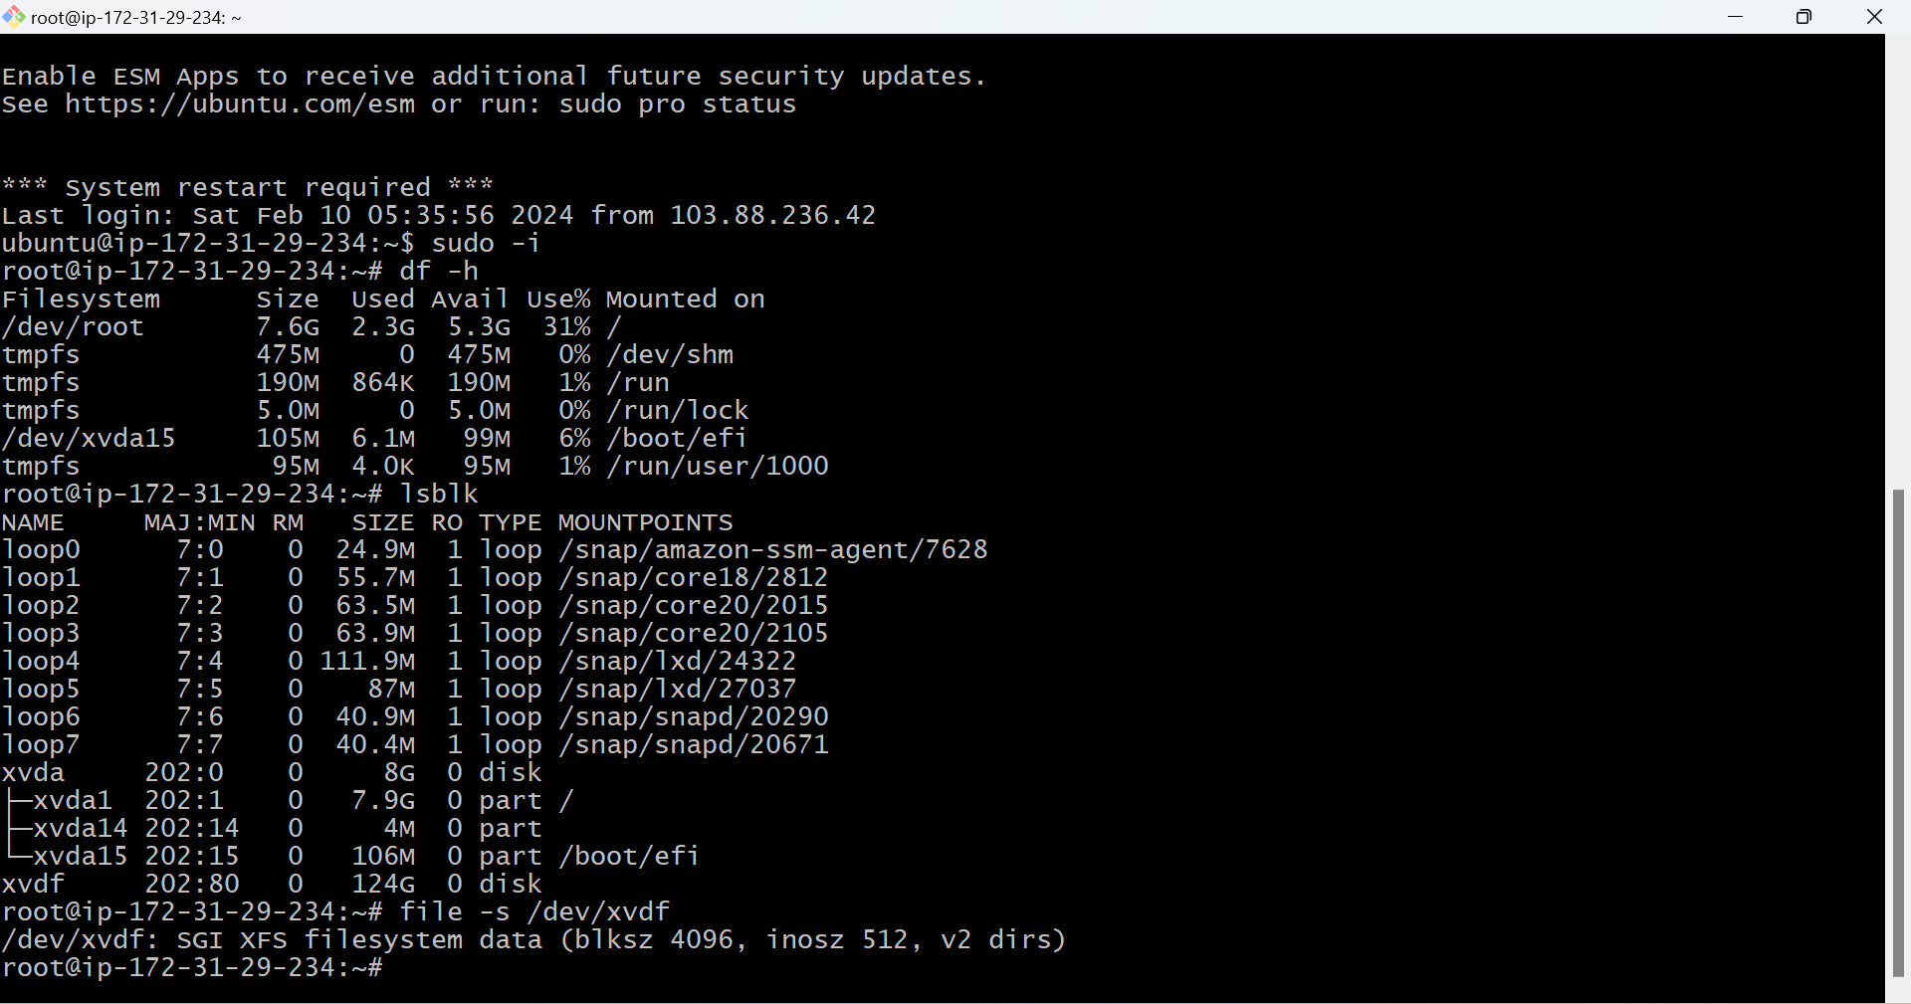

It shows that the already file exists.

**2. create efs and attach ebs to 3 different instances in 3 different availability zones.**

To create an EFS (Elastic File System) and attach an EBS (Elastic Block Store) volume to 3 different instances in 3 different availability zones, Sign in to the AWS Management Console.

1. **Open the Amazon EFS console at** [**https://console.aws.amazon.com/efs/**](https://console.aws.amazon.com/efs/)**.**
2. Click the "Create file system" button.
3. In the "Create file system" wizard, configure the file system settings:
   * Choose the desired VPC and specify the appropriate settings for your application(in this the vpc in default mode).
   * Select the availability zones for each mount target you want to create by checking the corresponding checkboxes.
   * Configure the appropriate file system settings for throughput and performance.
4. 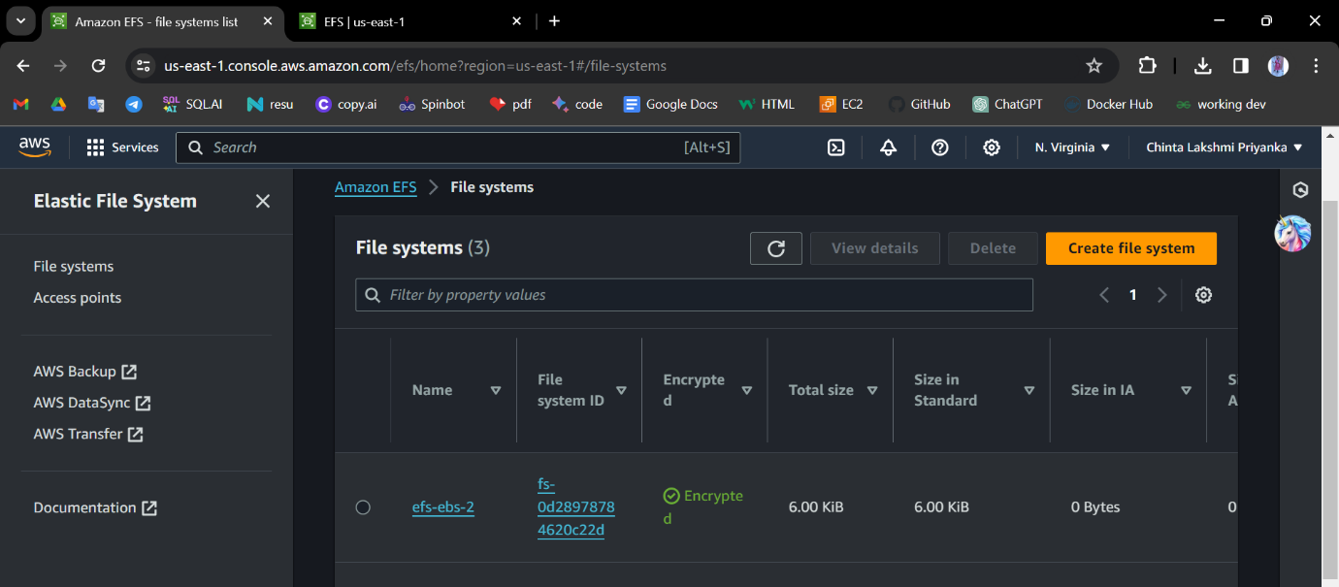Click the "Create file system" button to create the EFS file system.
5. Once the file system is created, select it, and note down the file system ID.

Now create 3 instances connect them to the instances and create file systems in different zones.

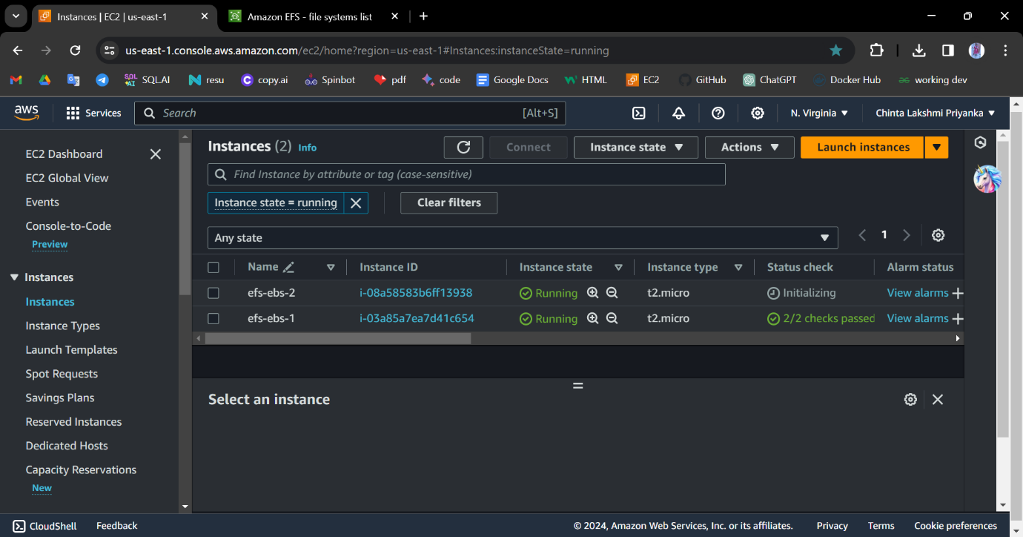

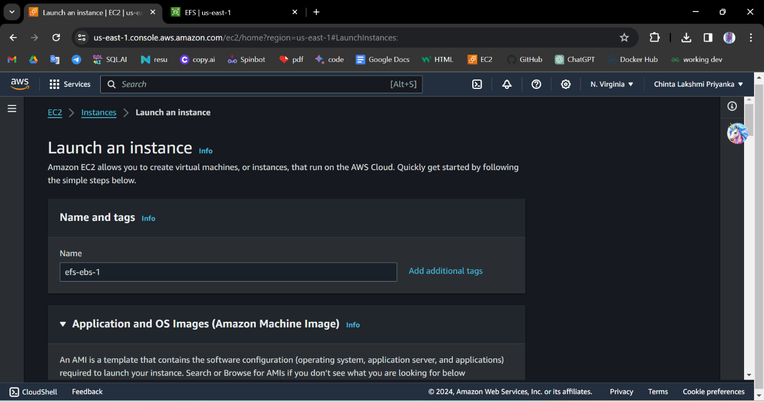Connect to the instances.

Now choose the subnet in the availability zone as us-east-1d.

And then edit network settings. In that choose the subnet add the security group and add the file system we created in the past

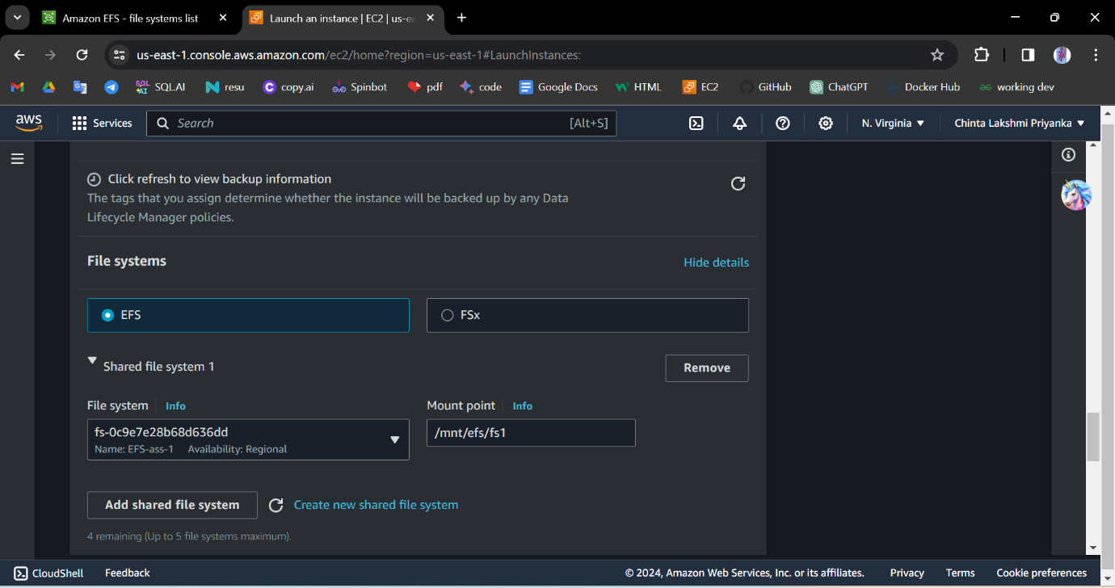Note the mount point**:/mnt/efs/fs1**

Launch the instance and connect to the instance

Now create a file system

Connect to the instance using sudo -i

Cd /mnt/efs/fs1

Vi file

Now create a file in fs1 and it is reflected in the second efs instance

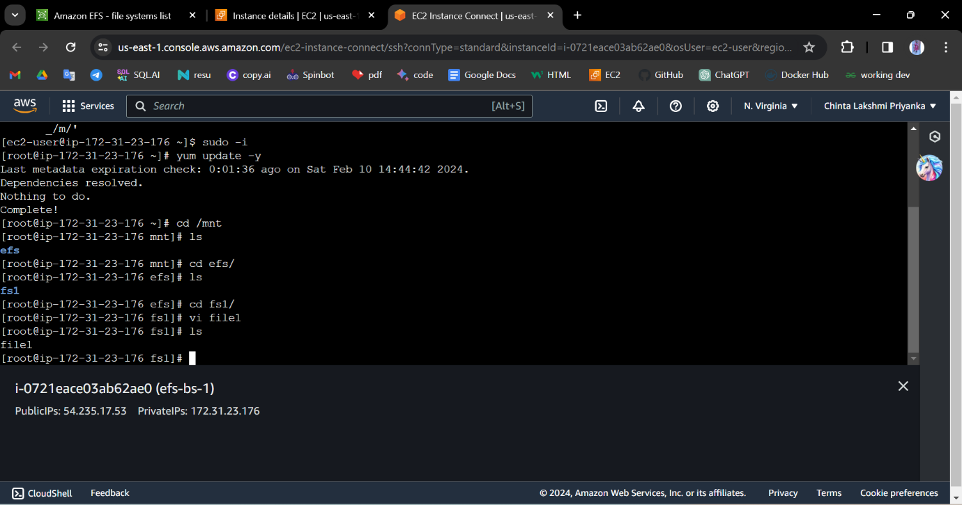

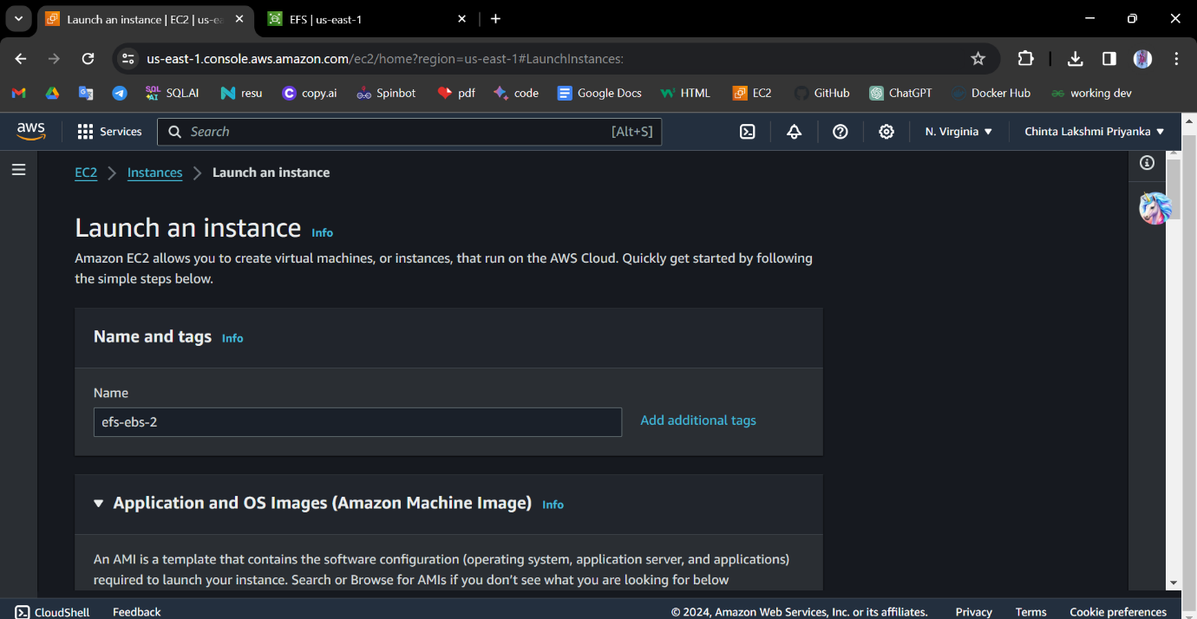Now create another instance and connect the instance.

Add existing security group.and edit network settings

And choose the availability subnet.

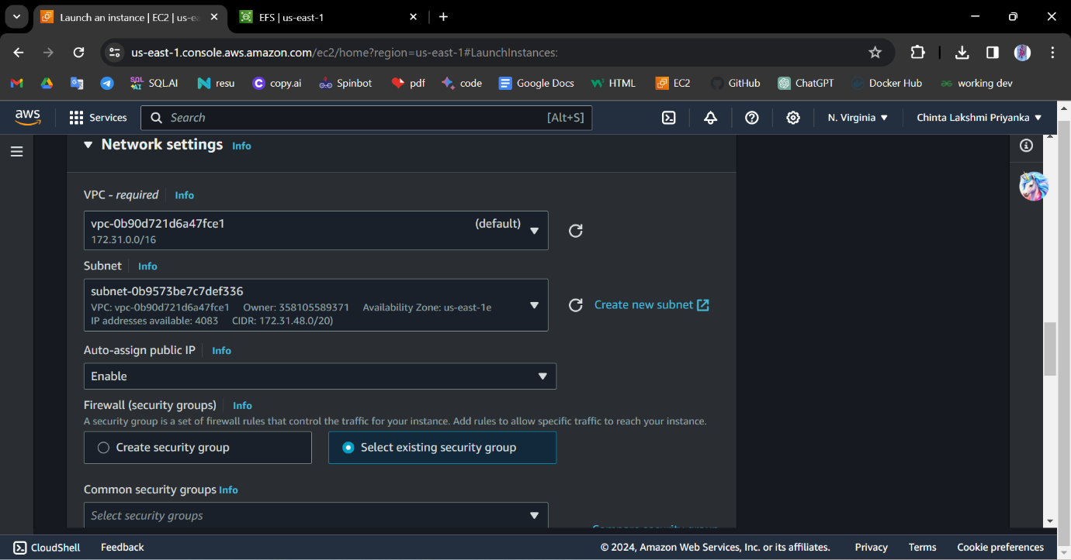

Now add the shared file system

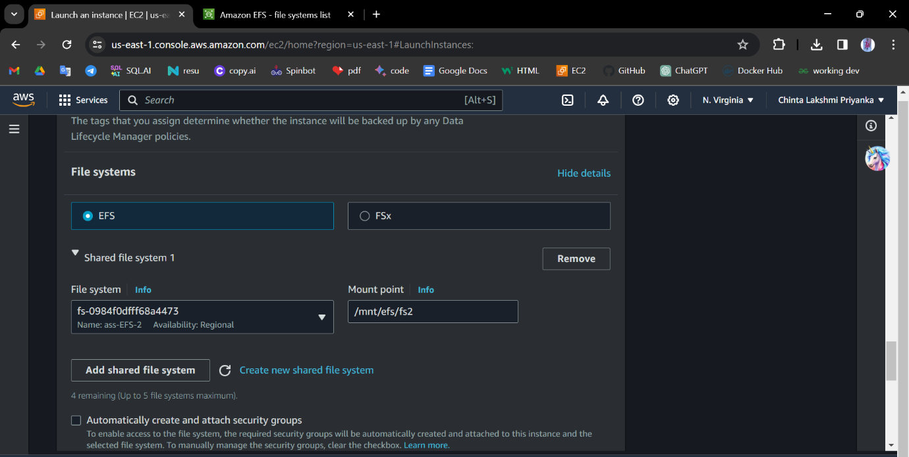

And launch the instance. connect the instance.

In this we have not created any file, but in instance -1 we have created the file. that file is reflected in this instance fs2.

Same as the shown these 2 instances. we have to create a third instance like this.

Now we have to create 3 ebs instances and check whether the file exits in

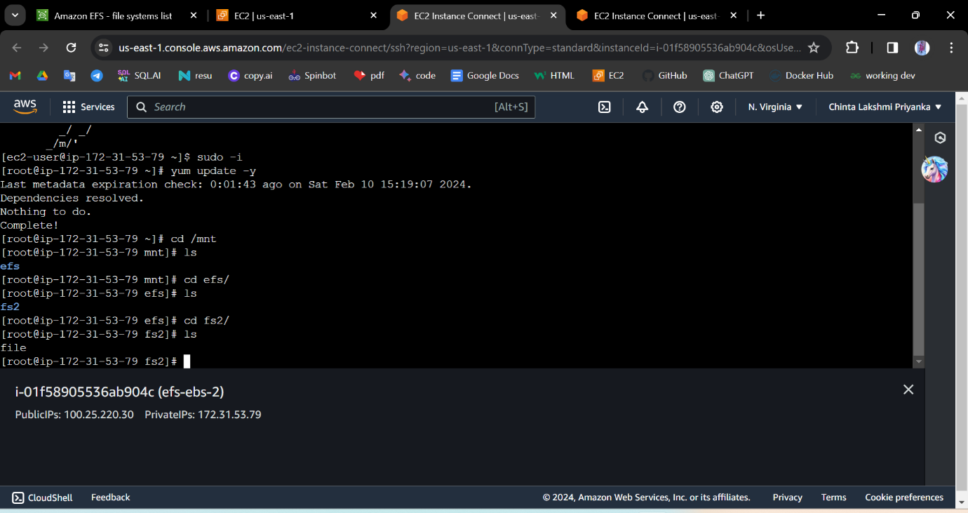

another 2 instances or not.

Now launch the first instance and connect the instance.

Now connect the instance

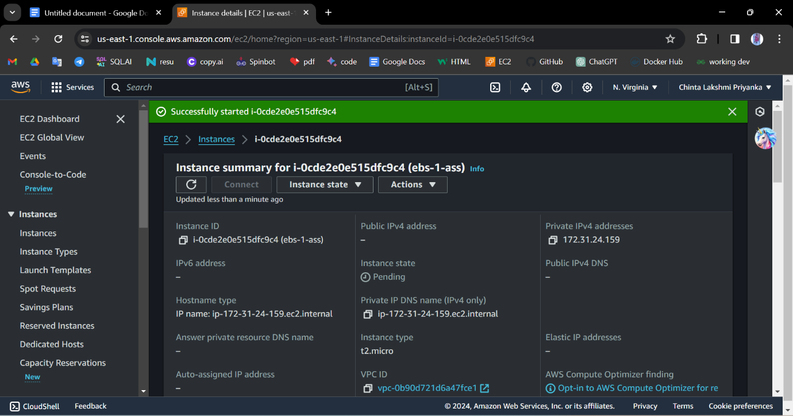

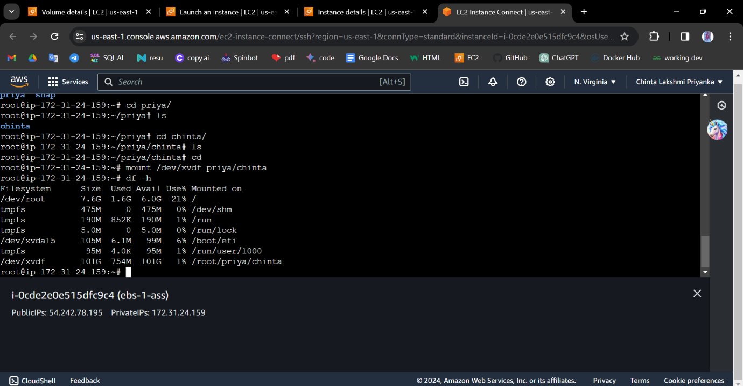

In this we have created a file system Now check if it was reflected to

another or not.

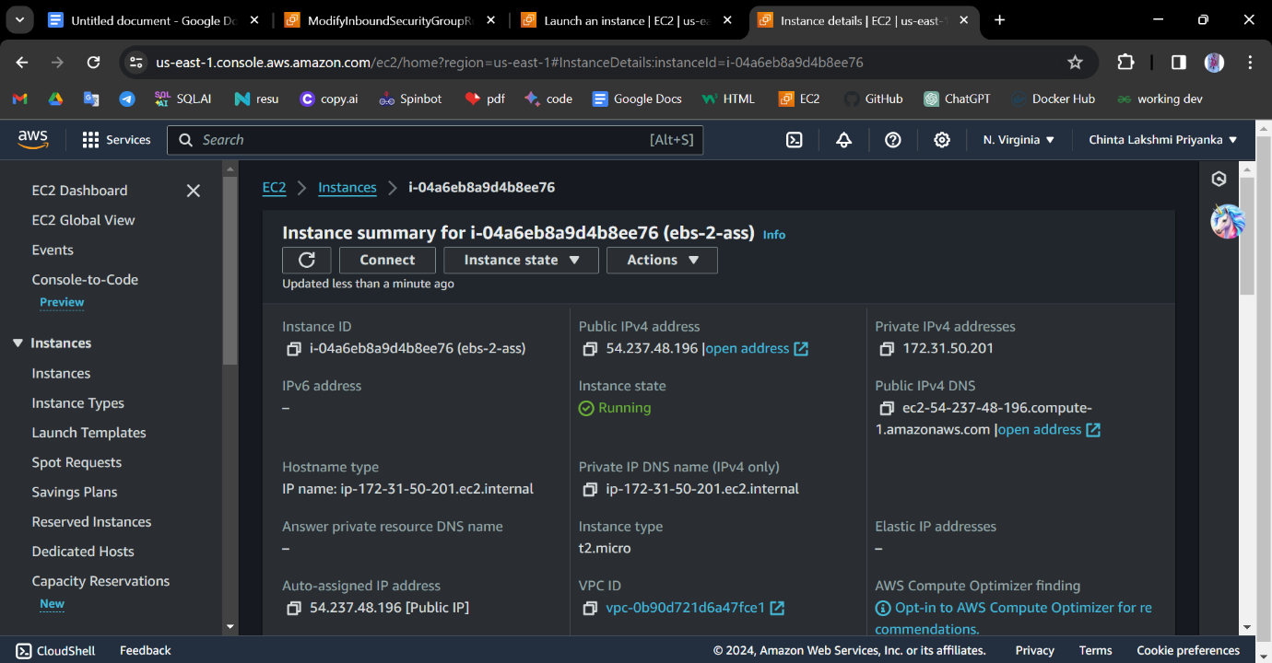Create a second instance

Now we have to check if is there any existing file in the system

Using file -s /dev/xvdf .is it does not exist it will go to the next step if not

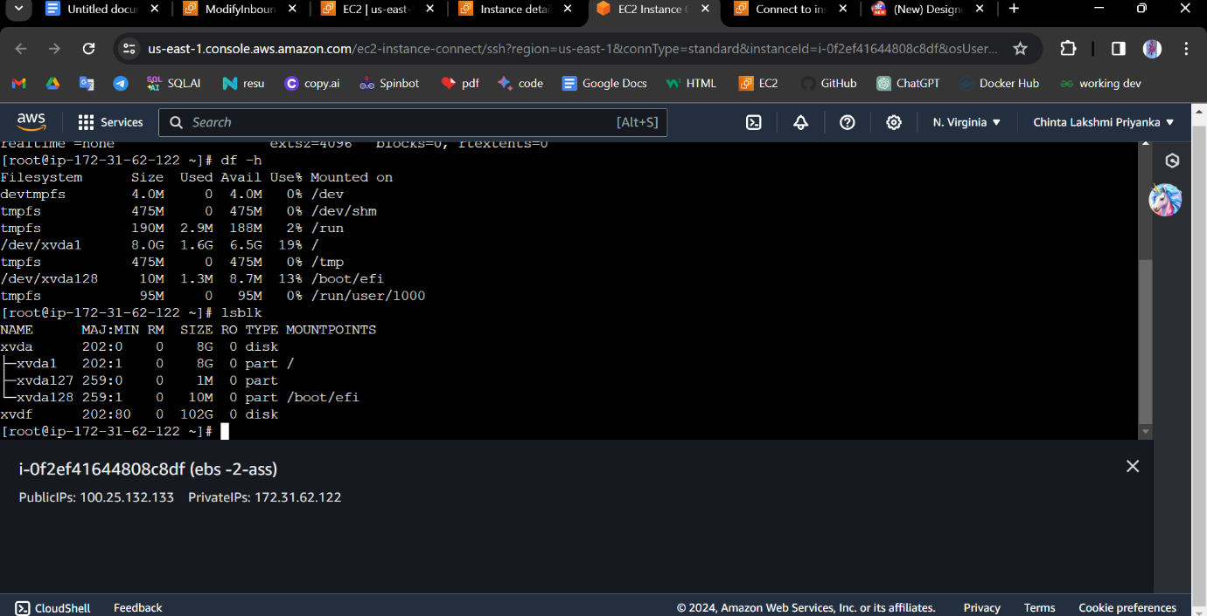We have to create a file system.

In this, the file was not reflected. we have to create a file system

Now as the 2 instances we have to create a third instance

And check whether the file system is created or not

It was not created.

**CONCLUSION:** Only in EFS did we have to create a file system and it was reflected in another instance. But in the EBS it was not reflected in another instance we had to create a new file system.

--------------------------------- End --------------------------------